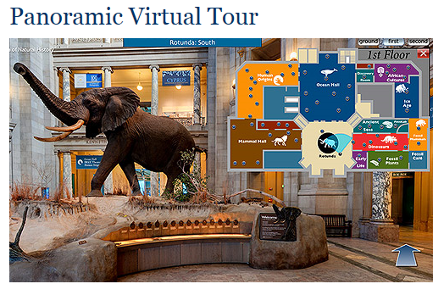
Take a Tour through the Past
This lesson focuses on the Mesozoic Era and Cenozoic Era’s. For this assessment you will Find an EXTINCT animal in the museum from either era and pretend you are interviewing them.
Smithsonian Museum of Natural History – Panoramic Virtual Tour
Click the opening image of the elephant to enter the virtual tour.. You can find the map in the upper right corner of your screen Go on a tour of the museum looking at all of the various animals that can be found there. Find 1 that interests you from the Mesozoic or Cenozoic Era. You will need to complete research on this animal to answer the questions for the interview that are provided for you.
Interview Question #1: What is your scientific name?
Interview Question #2: What is your common name?
Interview Question #3: What era were you found in? What period of that era were you found?
Interview Question #4: What do you look like? (discuss things like color, skin or feathers, how many legs, does it have a tail, etc.)
Interview Question #5: Did you live on the land or in the water? How did you move?
Interview Question #6: How did you communicate?
Interview Question #7: How long did your species live on the Earth? (example: from 125 million years ago to 65 million years ago)
Interview Question #8: Who were your predators?
Interview Question #9: What conditions happened to cause you to become extinct?
Interview Question #10: Tell me 3 interesting facts about you.
Interview Question #11: Where have scientists found fossils of you found today? List at least 3 places they have found them.
Attach a picture of your animal
Works Cited must be included

